# Hardcoded dictionary of stock prices
stock_prices = {
"AAPL": 180.0, # Apple
"TSLA": 250.0, # Tesla
"GOOGL": 2800.0, # Google
"MSFT": 300.0, # Microsoft
"AMZN": 3300.0 # Amazon
}

def calculate_portfolio():
portfolio = {} # Dictionary to store user's stocks and quantities
total_value = 0.0

print("Welcome to the Stock Portfolio Tracker!")
print("Available stocks and their prices:")
for stock, price in stock_prices.items():
print(f"{stock}: ${price}")

while True:
stock_name = input("\nEnter stock name (or 'done' to finish): ").upper().strip()
if stock_name == 'DONE':
break

if stock_name not in stock_prices:
print("Stock not found. Please enter a valid stock name.")
continue

try:
quantity = int(input(f"Enter quantity for {stock_name}: "))
if quantity <= 0:
print("Quantity must be a positive integer.")
continue
except ValueError:
print("Invalid quantity. Please enter a number.")
continue

# Add to portfolio
portfolio[stock_name] = portfolio.get(stock_name, 0) + quantity
value = stock_prices[stock_name] * quantity
total_value += value
print(f"Added {quantity} shares of {stock_name} at ${stock_prices[stock_name]} each. Value: ${value:.2f}")

# Display total investment
print(f"\nTotal Portfolio Value: ${total_value:.2f}")
print("Your Portfolio:")
for stock, qty in portfolio.items():
value = stock_prices[stock] * qty
print(f"{stock}: {qty} shares @ ${stock_prices[stock]} = ${value:.2f}")

# Optional: Save to file
save_option = input("\nDo you want to save your portfolio to a file? (yes/no): ").lower().strip()
if save_option == 'yes':
filename = input("Enter filename (e.g., portfolio.txt): ").strip()
if not filename:
filename = "portfolio.txt"

try:
with open(filename, 'w') as file:
file.write("Stock Portfolio Summary\n")
file.write("=" * 30 + "\n")
for stock, qty in portfolio.items():
value = stock_prices[stock] * qty
file.write(f"{stock}: {qty} shares @ ${stock_prices[stock]} = ${value:.2f}\n")
file.write(f"\nTotal Value: ${total_value:.2f}\n")
print(f"Portfolio saved to {filename}")
except Exception as e:
print(f"Error saving file: {e}")

# Run the tracker
if __name__ == "__main__":
calculate_portfolio()

Screen Shoot output

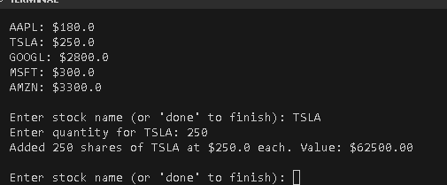

TASK 4: Basic Chatbot
Goal: Build a simple rule-based chatbot.

Scope:
  - Input from user like: "hello", "how are you", "bye".
  - Predefined replies like: "Hi!", "I'm fine, thanks!", "Goodbye!".
Key Concepts Used: if-elif, functions, loops, input/output.
def chatbot():
print("Hello! I'm a simple chatbot. Type 'bye' to exit.")

while True:
user_input = input("You: ").lower().strip()

if user_input == "hello":
print("Chatbot: Hi!")
elif user_input == "how are you":
print("Chatbot: I'm fine, thanks!")
elif user_input == "bye":
print("Chatbot: Goodbye!")
break
else:
print("Chatbot: I'm sorry, I don't understand that.")

# Run the chatbot
if __name__ == "__main__":
chatbot()

Screen Shot
